
Research & Vehicle Technology
“Infotainment Systems Product Development”

Feature – Off-road Front View Camera

APIM Infotainment Subsystem Part Specific Specification (SPSS)

Version 1.0
UNCONTROLLED COPY IF PRINTED

Version Date: May 31st, 2013

FORD CONFIDENTIALF

Revision History

Date | Version | Notes
May 31st, 2013 | 1.0 | Initial Release
Table of Contents
Revision History 2
1.1 Architectural Design 4
1.1.1 FAS-FVCv1-GCLD-266635-1-FrontViewCameraClient 4
1.1.2 FrontViewCameraClient Interface 4
1.2 General Requirements 6
1.3 Functional Definition 6
1.3.1 FAS-FVCv1-GFUN-293109-Feature Activation 6
1.4 Appendix: Reference Documents 11

Architectural Design

FAS-FVCv1-GCLD-266635-1-FrontViewCameraClient
Responsibility: The FrontViewCameraClient is the interface of the Front View Camera (FVC) feature. It displays the FVC image to the user and acts with other system parts that control the FVC or need data from it.

FrontViewCameraClient Interface

FAS-FVCv1-GIF-266657-1-FrontViewCameraClient_Rx

FrontCamera_St
(CAN Name: CamraFrntStat_D_Stat)

Message Type: Status

Vehicle status signal for enabling/disabling front camera feature.

Name | Literals | Value | Description
Type | - | - | -
 | OFF | 0x0
 | ON | 0x1
 | NotUsed | 0x2
 | NoData | 0x3

Elocker_St
(CAN Name: RearDiffLckLamp_D_Rq)

Message Type: Status

Vehicle status signal for displaying the Electric Differential Locker (Elocker) engagement message to the user.

Name | Literals | Value | Description
Type | - | - | -
 | OFF | 0x0
 | ON | 0x1
 | Flash | 0x2
 | Notused | 0x3

AwdRange_St
(CAN Name: AwdRnge_D_Actl)

Message Type: Status

Vehicle status signal for the state of the transfer box in terms of range and coupling locking.

"locked" means the AWD coupling / differential is locked.

"auto" means the AWD coupling / differential is under active control (could be locked, open or anywhere in between depending on system).

"2wd" means the AWD coupling is open.

Name | Literals | Value | Description
Type | - | - | -
 | LowRangeLocked | 0x0
 | LowRangeAuto | 0x1
 | LowRange2wd | 0x2
 | Neutral | 0x3
 | HighRangeLocked | 0x4
 | HighRangeAuto | 0x5
 | HighRange2wd | 0x6
 | Unknown | 0x7

OffRoadMode_St
(CAN Name: AwdOffRoadMode_D_Stats)

Message Type: Status

Vehicle status signal for the state of Off Road Mode.

Name | Literals | Value | Description
Type | - | - | -
 | NormalMode | 0x0
 | OffRoad | 0x1
 | ExtemeOffRoad | 0x2
 | Invalid | 0x3

GearLvrPos_D_Actl
Message Type: Status

Vehicle status signal for the Gear Lever Position on an automatic transmission vehicle.

Name | Literals | Value | Description
Type | - | - | -
 | Park | 0x0
 | Reverse | 0x1
 | Neutral | 0x2
 | Drive | 0x3
 | Sport_DriveSport | 0x4
 | Low | 0x5
 | First | 0x6
 | Second | 0x7
 | Third | 0x8
 | Fourth | 0x9
 | Fifth | 0xA
 | Sixth | 0xB
 | Undefined_Treat_as_Fault | 0xC
 | Undefined_Treat_as_Fault1 | 0xD
 | Unknown_Position | 0xE
 | Fault | 0xF

GearRvrseActv_D_Actl
Message Type: Status

Vehicle status signal for notifying that Reverse Gear is engaged on a manual transmission vehicle.

Name | Literals | Value | Description
Type | - | - | -
 | Inactive | 0x0
 | Active | 0x1
 | Unknown | 0x2
 | Fault | 0x3

VehicleSpeed_St
Message Type: Status

Status used to indicate vehicle speed.

Name | Literals | Value | Description
Type | - | - | Indicates vehicle speed.  Unit: kph  Resolution:0.01  Offset:0
 | kph | 0x0 to 0xFFFF

General Requirements
FAS-FVCv1-GREQ-266605-1-Handling Rear Camera Delay Mode (Functional) -
When front view camera is enabled (FrontCamera_St = ON), the rear view camera delay mode setting is ignored by the FrontViewCameraClient (Front camera image takes precedence over Rear camera image when vehicle is in forward gear).

Functional Definition

FAS-FVCv1-GFUN-293109-Feature Activation

Requirements
FAS-FVCv1-GREQ-266606-1-Front View Camera Activation Hysteresis (Functional) -
The FrontViewCameraClient shall use a hysteresis window around the activation speed threshold for front view camera of 2 mph and 100 ms.
Example:
1) The vehicle is driving forward, at less than 15 mph (All conditions for showing front video are true). Front camera image is shown by the FrontViewCameraClient.
2) The vehicle exceeds 15 mph for greater than 100 ms. The front camera image is no longer shown by the FrontViewCameraClient.
3) The vehicle slows down to 13 mph for greater than 100ms. The front camera image is shown again by the FrontViewCameraClient.

FAS-FVCv1-GREQ-267522-1-Deactivate FVC (Functional) -
The FrontViewCameraClient shall stop displaying Front View Camera (FVC) image when one of the following conditions is met:
• Vehicle is shifted into 'Reverse' (Rear View Camera image will be shown)
• Vehicle is shifted into 'Park' (No Image shown in 'Park')
• Power Mode does not equal IgnitionOn_2 or Running_2 or Crank_3
• FVC is disabled (FrontCamera_St = 0x0:OFF)
• Vehicle speed exceeds 15 mph
• Vehicle no longer meets the following conditions:
1) 4x4 transfer case is locked in 4L (AwdRange_St = 0x0:LowRangeLocked)

or

2) Off-Road Mode is on (OffRoadMode_St = 0x1:OffRoad or 0x2:ExtremeOffRoad)
and
E-Locker is locked (Elocker_St = 0x1:ON)

FAS-FVCv1-GREQ-266607-1-E-Locker Deactivation Delay (Functional) -
If the FrontViewCameraClient is displaying the Front View Camera (FVC) image (all conditions for front camera image display are true) and the E-Locker transistions from 'Locked' (Elocker_St = 0x1:ON) to 'Unlocked' (Elocker_St = 0x0:OFF), the FrontViewCameraClient shall start a timer (T_eLockerDelay) and shall continue to display the FVC image until the expiration of this timer.

If the FrontViewCameraClient detects that the E-Locker transistions back to 'Locked' prior to the expiration of T_eLockerDelay, and all other conditions for front camera image remain true, the FrontViewCameraClient shall cancel the timer and continue to display the FVC image.

Requirement# | Name | Description | Units | Range | Resolution | Default
FAS-FVCv1-GREQ-266609-1-T_eLockerDelay | T_eLockerDelay | Maximum time FrontViewCameraClient should wait before stopping the display of the FVC video image to the user according to FAS-FVC-GREQ-266607-E-Locker Deactivation Delay. | msec | 4975-5025 | 5.0 | 5,000.0

Use Cases

FAS-FVCv1-GUC-290140-Activate Front View Camera
Linked Elements
[266606-1] FAS-FVCv1-GREQ-266606-1-Front View Camera Activation Hysteresis
[290141] FAS-FVCv1-GUC-290141-Front View Camera Malfunction
[293097] FAS-FVCv1-GSD-293097-Activate_Deactivate Front View Camera
[293109] FAS-FVCv1-GFUN-293109-Feature Activation

Actors | Vehicle Occupant
Pre-conditions | • The ignition status is Run/Start.  • The front view camera feature is enabled.  • The Vehicle Speed is less than 15 mph.  • The gear position status is not Park and not Reverse.  • The 4x4 transfer case is locked in 4L.  or  The Off-Road Mode is on and the E-Locker is locked.
Scenario Description | The user activates the front view camera by placing the vehicle in forward Gear.
Post-conditions | The vehicle system display shows Front View Camera (FVC) image.
List of Exception Use Cases | E1 – Front View Camera Malfunction
Interfaces | G-HMI  Vehicle System Interface

FAS-FVCv1-GUC-290141-Front View Camera Malfunction
Linked Elements
[290140] FAS-FVCv1-GUC-290140-Activate Front View Camera
[293109] FAS-FVCv1-GFUN-293109-Feature Activation

Actors | Vehicle Occupant
Pre-conditions | • The ignition status is Run/Start.  • The front view camera feature is enabled.  • The Vehicle Speed is less than 15 mph.  • The gear position status is not Park and not Reverse.  • The 4x4 transfer case is locked in 4L.  or  The Off-Road Mode is on and the E-Locker is locked.
Scenario Description | The Front View Camera (FVC) video cannot be shown because of a malfunction.
Post-conditions | The FVC user interface (vehicle system display) indicates that the FVC video cannot be shown because of a malfunction.
List of Exception Use Cases
Interfaces | G-HMI  Vehicle System Interface

FAS-FVCv1-GUC-290142-Deactivate Front View Camera
Linked Elements
[266607-1] FAS-FVCv1-GREQ-266607-1-E-Locker Deactivation Delay
[267522-1] FAS-FVCv1-GREQ-267522-1-Deactivate FVC
[293097] FAS-FVCv1-GSD-293097-Activate_Deactivate Front View Camera
[293109] FAS-FVCv1-GFUN-293109-Feature Activation

Actors | Vehicle Occupant
Pre-conditions | The ignition status is Run/Start.  The vehicle system display is showing front view camera image.
Scenario Description | The user deactivates the front view camera by any of the following:  • Shifting the vehicle into Reverse gear (RVC image will be shown)  • Shifting the vehicle into Park (No image shown in 'Park')  • Disabling front view camera  • Exceeding the speed threshold (15 mph)  • No longer meeting the following conditions:  1) 4x4 transfer case is locked in  or  2) Off-Road Mode is on  and  E-Locker is locked
Post-conditions | The vehicle system display is NOT showing front view camera image.
List of Exception Use Cases
Interfaces | G-HMI  Vehicle System Interface

White Box View

Activity Diagrams
FAS-FVCv1-GAD-293107-Front View Camera Activation
Linked Elements

Activity Diagram
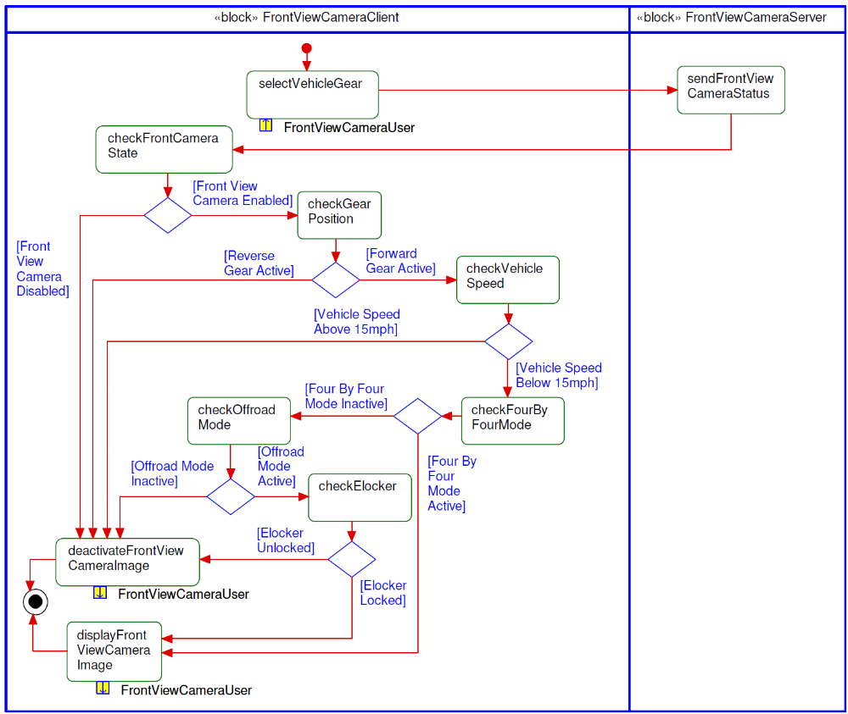

Sequence Diagrams
FAS-FVCv1-GSD-293097-Activate_Deactivate Front View Camera
Linked Elements
[290140] FAS-FVCv1-GUC-290140-Activate Front View Camera
[290142] FAS-FVCv1-GUC-290142-Deactivate Front View Camera
[293107] FAS-FVCv1-GAD-293107-Front View Camera Activation

Scenarios

Normal Usage
The front camera is activated or deactivate by driver actions (vehicle gear selection, four by four mode selected, etc.).
Constraints

Pre-condition
Power Mode = IgnitionOn_2 or Running_2 or Crank_3

Post-condition
The appropriate camera image is displayed to the driver.

Sequence Diagram
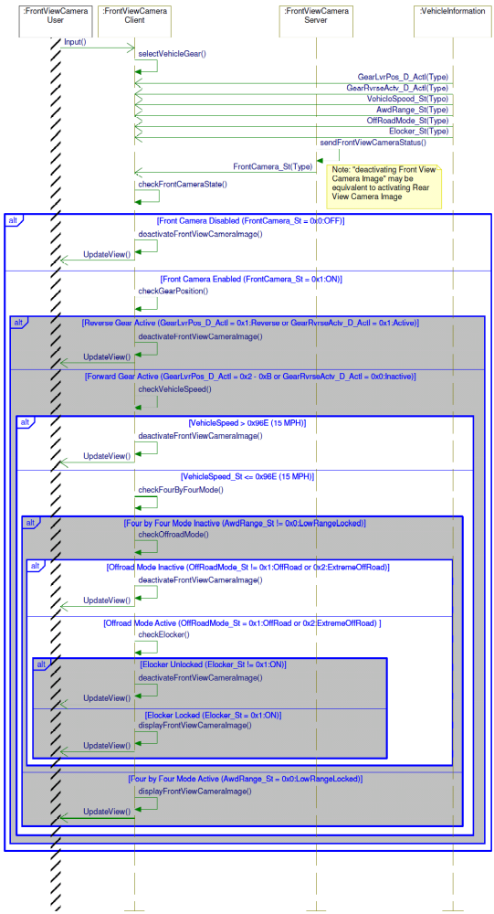

Appendix: Reference Documents
Reference # | Document Title
1
2
3
4
5

